**PROJECT REPORT 2019(SPECTROPHOTOMETER)**



**Submitted To:**

Dr. Naveen Aggarwal

**Submitted By:**

DEEPANSHU BAIDHWAN

BE(EEE)-3rd year

UE164021

**ABSTRACT:**

It is known that every chemical compound or substance transmits, reflects or absorbs a certain range of wavelength in electromagnetic spectrum and this transmittance or absorbance by a particular compound is measured is the study of spectrophotometry. It is employed largely for quantitative analysis in various domains such as chemistry, biology, biochemistry, physics,chemical and material engineering, applications at clinical or industrial level, etc.

An application that involves the chemical compounds or materials can use this technique. For example, in the field of biochemistry, it is applied for determining enzyme-catalysed reactions by studying the absorbance over a period of time at certain intervals. In case of clinical applications, it is employed for examining blood or tissues for the purpose of diagnosis.

Also,there are many variations among spectrophotometry. Some examples are atomic absorption spectrophotometry or atomic emission spectrophotometry

The main aim of building this device , is check the concentration and the absorption rate of any particular liquid, and through this information we are able to find various properties of the liquid. Our main concern is to reduce the price of spectrophotometer. As originally our UV spectrophotometer cost varies from Rs 50,000 to 1 lakh. But our device cost us just Rs 10,000 approximately. So we are focusing on this thing that our low cost spectrophotometer

Show same result as our original spectrophotometer.

**INDEX:**

* INTRODUCTION
* PROBLEM STATEMENT
* RELATED SOLUTION
* DESIGN CHALLENGES AND ISSUES
* DIFFERENT ALTERNATIVES TO SOLVE
* SOFTWARE AND PROGRAMMING USED
* TESTING STRATIGIES
* RESULTS
* CONCLUSION
* FURTHER SCOPE
* REFRENCE

**CERTIFICATE OF ORIGINALITY**

We hereby declare that we are responsible for the work submitted in this project, this work is our own original work, and that neither the report nor the original work contained therein has been submitted to this or any other institution. All sources used for the project have been fully and properly cited.

Students involved in the project

DEEPANSHU BAIDHWAN

.................................... ( Signed )

..................................... ( Date)

Mentor: Dr. Naveen Aggarwal, UIET Panjab University

I verify that that statements provided above are true and the work carried out by them is

authentic.

Signature of Mentor:

.................................... ( Signed )

..................................... ( Date)

**INTRODUCTION:**

Spectrometry can be defined as the study of how light interacts with matter, by analysing the measurements and reactions of wavelength of light and its radiation intensity. It cannot be called a unique or specialized field but it is an integral component of the scientific processes under a variety of disciplines like physics, chemistry, material and chemical engineering, biochemistry, and clinical applications. Spectrophotometry is a technique to measure the amount of light that a chemical substance absorbs. It is done by measuring the power or intensity of light that passes through the sample solution in the form of a beam. The principle

Behind this technique is that a substance absorbs or transmits light over a particular range of wavelength spectrum. This method can also be employed to measure the amount or concentration of a known chemical in the sample.

It is known that every chemical compound or substance transmits, reflects or absorbs a certain range of wavelength in electromagnetic spectrum and this transmittance or absorbance by a particular compound is measured is the study of spectrophotometry. It is employed largely for quantitative analysis in various domains such as chemistry, biology, biochemistry, physics, chemical and material engineering, applications at clinical or industrial level, etc. An application that involves the chemical compounds or materials can use this technique. For

example, in the field of biochemistry, it is applied for determining enzyme-catalysed reactions by studying the absorbance over a period of time at certain intervals. In case of clinical applications, it is employed for examining blood or tissues for the purpose of diagnosis. Also, there are many variations among spectrophotometry. Some examples are atomic absorption spectrophotometer or atomic emission spectrophotometry

A spectrophotometer can be defined as an instrument that measures the rate of photons absorbed after the light passes through the sample solution. The number of photons is determined by measuring the intensity of light. Using this, the concentration of a known chemical compound can also be estimated. Depending on the range of wavelength of light source, it can be classified into two different types:

UV-visible spectrophotometer: It uses light over the range 185 - 400 nm, that is ultraviolet range, and 400 - 700 nm, that is visible range, of the electromagnetic radiation spectrum.

In visible spectrophotometry, certain substances can be analysed by observing the colour of the transmission or the absorption. Consider a case where a sample solution absorbs light over all visible ranges. Such solution appears to be black theoretically. In other case, if a sample solution transmits all visible wavelengths it appears to be white, that is transparent to all colours of light. In a case, if a solution absorbs red light it will transmit or reflect green light and thus appear to be green. This is because green is the complementary colour of red.

Spectrophotometers practically use a prism to narrow down a certain range of wavelengths being transmitted and block other wavelengths so that only a particular range of light is passed through solution.

IR spectrophotometer: uses light over the range of range 700 - 15000 nm, that is Infrared, of the electromagnetic radiation spectrum.

**PROBLEM STATEMENT:**

In biochemistry there is need for checking the concentration and absorption of a particular liquid. Through this we are able to calculate various properties of tha substance. Everyone is not able to afford a high cost spectrophotometer.So for a biology student its important to know liquids concentration. In school laboratory also students are not given proper demonstration of how the absorption of light take place in an liquid or how the light is being transmitted and reflected through an medium. In medical science also doctor should know the concentration of various substance present in human blood.For an normal milk vendor also it is important to calculate the concentration of water in an milk

**RELATED SOLUTION:**

So for calculating the concentration of varios liquids and study the various properties of an particular liquid we have come with an instrument known as spectrophotometer. Through this the students in the school are able to observe the various absorption properties of liquid and are also able to study the transmitted and reflected light after passing through a medium.

Through this the doctors are able to calculate the concentration of substances present in an human blood and can propose some solution to overcome the problem. Through this spectrophotometer the milk wender is able to calculate the concentration of water in a milk solution.

**DESIGN  CHALLENGES AND ISSUES:**

In this our low cost spectrophotometer we have come across various problems. We have worked hard on how to make the results same as the original UV spectrophotometer. Also our other main concern was to make this instrument user friendly so that any person can use this instrument without any issues. In our instrument the light source(RGB light)  we are using is do not give the appropriate readings. Also the installation of “raspbain OS” first time on the raspberry pi is faced with a lot of problems .There is an connection issue of pi with laptop through ethernet cable, the connection is not always established.In this raspberry pi the LCD we are using have a connection with i2c bus and the TSL which we are using is also using this i2c communication method . So for this we need more than one i2c communication buses so that both our sensor and LCD screen could work at the same time. Also connecting 5” LCD screen with raspberry pi3 the screen shows only white window and nothing else.

**DIFFERENT ALTERNATIVE TO SOLVE THE PROBLEM:**

So we have to solve all the problem, so that our instrument is being easily used by other pearson who wants to calculate the appropriate results. So for the light source we can change our original light source(RGB light whose range is 300nm-750nm) we can change this with xenon flash lamp(Range 200nm-100nm). Also for installing raspbian os first you have to burn the software in the SD card and the for the first time to run this OS connect your raspberry pi with HDMI with the Desktop so the OS should write in the raspberry pi..So for connection of Pi with laptops we can make an local area network (eg mobile hotspot). Through this LAN connect your laptop and raspberry pi3B. Now to check the IP address of this LAN , open the terminal in the raspberry pi and type”sudo raspi-config” to check the IP address. Now open “moba extreme” in the laptop and connect write this IP in this software to connect it with pi.

So for connection of sensor and the LCD screen both with Raspberry pi through i2c communication we have to add an additional i2c bus 3 in the pi. Through this we have to change the i2c pins for the luminosity sensor.  So for multiple i2c bus go to the boot folder in raspberry pi and there is config.txt file is there. Edit it by typing “sudo nano config.txt” in the terminal window. There type “dtoverlay=i2c-gpio,i2x_gpio_sda=5,i2c_gpio_scl=6” and press ctrl+x and then save this experiment. Now the new gpio pins 5 and 6 will be your new i2c pins. So now connect your screen with raspberry pi through HDMI cable we have to add addition HDmi setting in raspberry pi3. To do this open the same config.txt file and there type”hdmi_group=2 hdmi_mode=87 hdmi_cvt 800 480 60 6 0 0 0 “ for 5” screen and then save it by pressing ctrl+x.

**DETAILED STEPWISE METHODOLOGY ADOPTED:**

Here is the step by step methodology adopted

Step1: First connect all sensors, light source, power supply and screen with the raspberry pi3

Step2: Then switch on the supply and check that the sensor is working properly and is connected by raspberry pi. To do this type ”sudo i2cdetect -y 1 or sudo i2cdetect -y 3” on terminal of the pi.

Step3: Now after checking all the connections established, run the code by going through the terminal.

Step4: Now the gui will open and first put simple water in the cuvette and put that cuvinte in the model .After that click on the Start baseline solution button in the GUI to start the experiment.

Step5 : After the baseline solution is done replace the cuvette with the sampled solution which you want to measure. And the click on the Start solution button on the GUI to calculate the readings of the sampled solution.

Step 6: After this the baseline sample and the sampled solution is done click on the plot button to plot the graph of the absorption vs wavelength graph.

Now the hardware part:

* Raspberry pi3 module:

It is the module combined of 1.4GHz 64-bit quad-core processor, dual-band wireless LAN, Bluetooth 4.2/BLE, faster Ethernet, and Power-over-Ethernet support (with separate PoE HAT).our Raspberry Pi doesn’t have a power switch: as soon as you connect it to a power outlet, it will turn on. Notice that the Pi’s micro USB power port has a longer flat side on top.It consist of 40 GPIO pins in it. Moreover it have an inbuilt wifi module, HDMI port, usb port, ethernet port ,audio jack port etc in it.

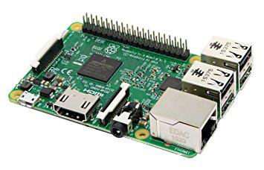

* Luminosity sensor(TSL2561):

The TSL2561 Intensity Sensor is a complex light sensor which gives a

flat response over most of the visible spectrum. The sensor measures both infrared and visible light to render a response better than the human-eye. It is an integrating sensor which means that it sinks light for a certain time period. Hence, it has capacity to detect both small and large amounts of light. The sensor can communicate directly using I2C protocol and can conduct light ranges from 0.1 - 40k+ lux. Moreover, the sensor consists of 2 integrating ADCs thatsimultaneously integrate currents of 2 photodiodes. It requires a supply voltage of 3V and acurrent of 0.6mA. It is a low-cost sensor, which detects the intensity of radiation in both visible and infrared range of spectrum. The range of this sensor varies from 0 lux to 40,000 lux depending upon the number of photons that hit its diode.

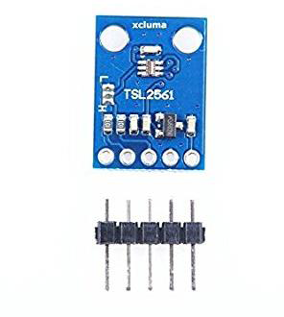

* RGB light source:

In place of the light source, an RGB LED is used. RGB LEDs combine three colours that can generate over 16 million hues of light. Being a cheap source of light with a potential to emit light over a wide spectral range (visible), it is an ideal fit for substituting the light source of a spectrophotometer [8]. When placed at a suitable distance, it emits a beam powerful enough to pass through the sample to perform the experiments. With different inputs to control red, green and blue light, it also provides the ability to control the wavelength of light emitted. This can be done by controlling the power of light emitted in the form of red, green and blue colours. The current, or indirectly the power sent through each pin of the LED can be controlled by regulating the duty-cycle. A wave with higher duty-cycle sends more current and hence more power to the LED. Higher power increases the intensity of light output by the LED.Different combinations of intensity of red, green and blue help generating light of different wavelengths.

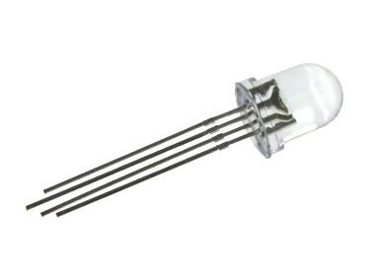

* Test tubes and cuvvets:

Test tubes are used for initial experiments instead of using optical grade quartz cuvettes to cut down cost factor. These are used to hold the sample and transmit light through them. The test tubes are made of borosil and are transparent to visible light. These test tubes can however not be used for other ranges of spectrum like UV (below 350nm) and IR range as they show absorption properties in these ranges.Being cylindrical in shape, the pose a limitation of spreading the light inconsistently over the surface. These test tubes come in different sizes and brands. However, optical grade quartz cuvettes can be used to avoid the limitations of borosil glass test tubes.

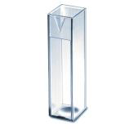

* Display device:

Display devices are used to output the result and make it available to the user for analysis. In the prototype, the display device is either a monitor or raspberry pi is remotely accessed on laptop screen. An 5” LCD display can also be used with raspberry pi to output the values and plots of experiment.

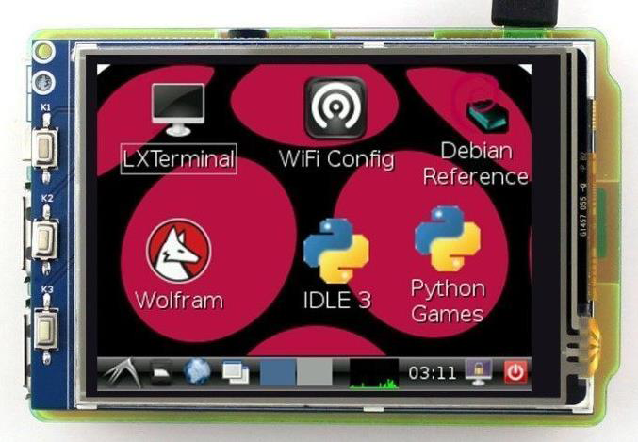

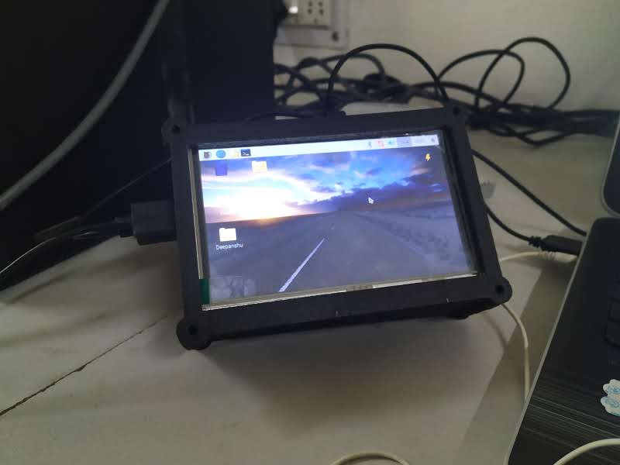

**SOFTWARES AND PROGGRAMING USED:**

1. The main gui page when nothing is done.

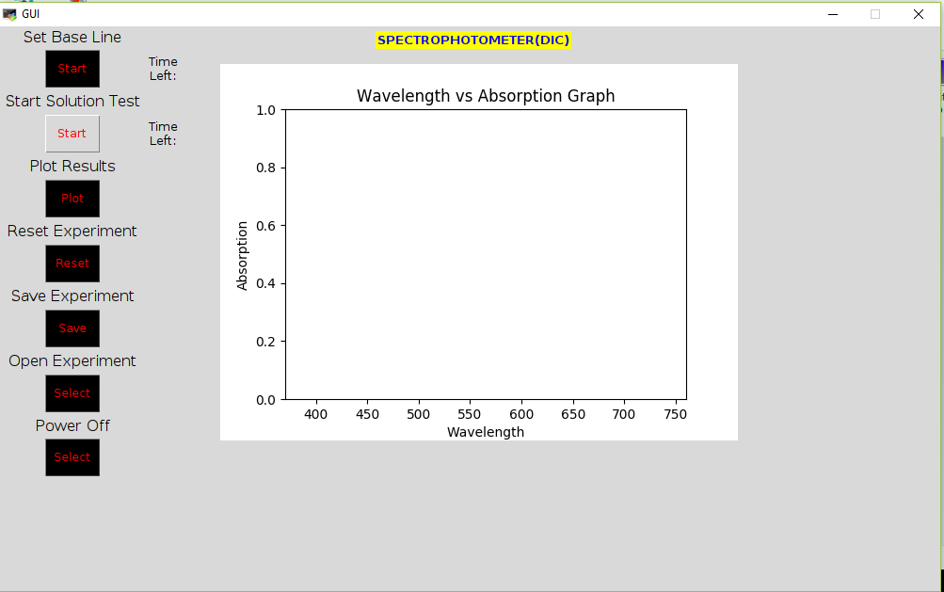

1. The page when baseline solution is tested

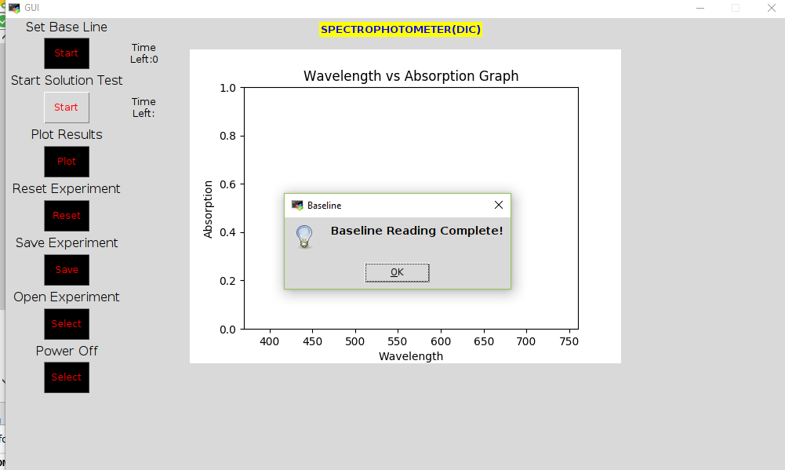

1. The gui when sampled solution is also tested.

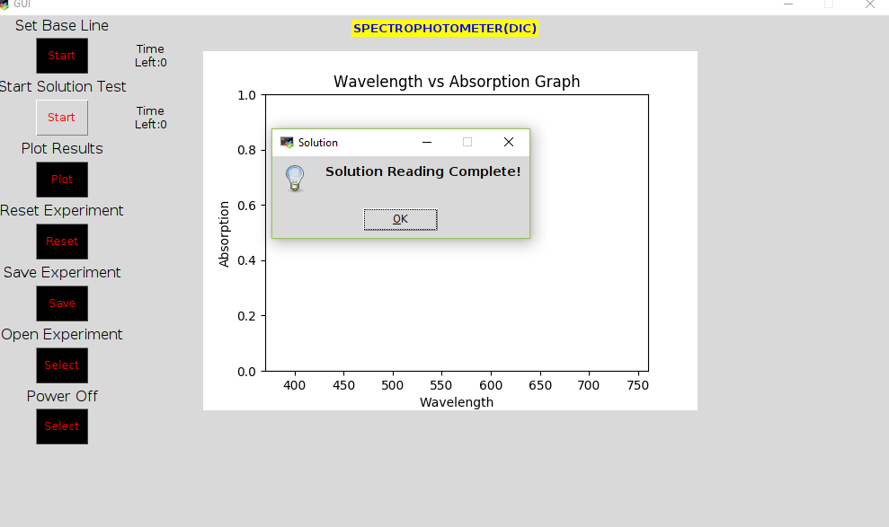

1. GUI when the graph have been plotted

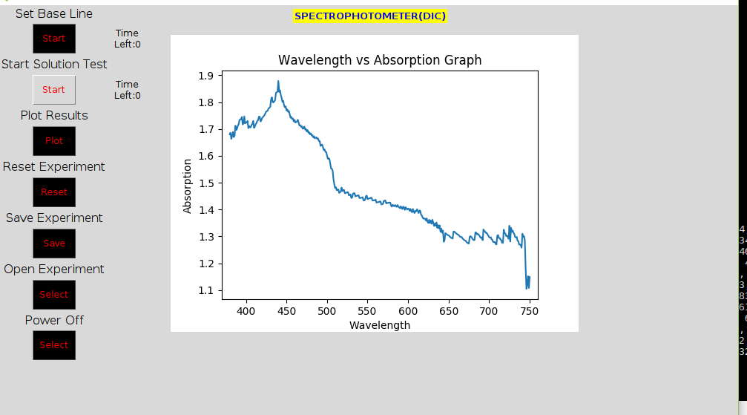

Python shell(Gene my):

In this shell the python script is been written.Python is an [interpreted](https://en.wikipedia.org/wiki/Interpreted_language), [high-level](https://en.wikipedia.org/wiki/High-level_programming_language), [general-purpose](https://en.wikipedia.org/wiki/General-purpose_programming_language) [programming language](https://en.wikipedia.org/wiki/Programming_language). Created by [Guido van Rossum](https://en.wikipedia.org/wiki/Guido_van_Rossum) and first released in 1991, Python has a design philosophy that emphasizes [code readability](https://en.wikipedia.org/wiki/Code_readability), notably using [significant whitespace](https://en.wikipedia.org/wiki/Off-side_rule). It provides constructs that enable clear programming on both small and large scales Van Rossum led the language community until July 2018.

Python is [dynamically typed](https://en.wikipedia.org/wiki/Dynamic_programming_language) and [garbage-collected](https://en.wikipedia.org/wiki/Garbage_collection_(computer_science)). It supports multiple [programming paradigms](https://en.wikipedia.org/wiki/Programming_paradigm), including [procedural](https://en.wikipedia.org/wiki/Procedural_programming), [object-oriented](https://en.wikipedia.org/wiki/Object-oriented_programming), and [functional programming](https://en.wikipedia.org/wiki/Functional_programming). Python features a comprehensive [standard library](https://en.wikipedia.org/wiki/Standard_library), and is referred to as "batteries included".

Libraries used in this are:

* RAsp.GPIO - This library is used for assigning the GPIO pins of raspberry pi function.There are two ways of numbering the IO pins on a Raspberry Pi within RPi.GPIO. The first is using the BOARD numbering system. This refers to the pin numbers on the P1 header of the Raspberry Pi board. The advantage of using this numbering system is that your hardware will always work, regardless of the board revision of the RPi. You will not need to rewire your connector or change your code.
* Smbus-This library is used for serial i2c real time communication of the sensor with the raspberry pi3 model
* Tkinter-This is used for designing the GUI interface and its functioning.
* Matplotlib- This is used for  plotting the graph and various figures on the GUI
* Time- This is used for giving timer to our current operation working
* Threading - This is used for doing multiple work by raspberry pi at a same time.(Like turning on the source light and collecting data from the Light sensor)
* Tkmessagebox- this is used for showing the completion of any task pop up window.
* Openpyxl- This is used for saving all your data in excel sheet

**TESTING STRATEGY:**

1. Salt solution test: In this we have to calculate the Salt level in the particular liquid. In this we have to apply various steps

* First put plain water in the cuvette and start the test for that plain water
* After that take on test tube of water and add 1 spoon of salt (Nacl) to it and mix it. Then put this solution in the cuvette and take reading of this sampled solution. Now plot the graph.
* Now again repeat this step 1 and now add 2 spoon of salt to the test tube filled with water. Mix them and pour that solution in the cuvette. And calculate these readings of the sampled solution. And then plot the graph.
* Now for next test add 3 spoons of salt and plot the graph
* Now add 4 spoons of salt and plot the graph
* At the end plot all the 4 graphs on on graph sheet only

2) Sugar solution test: In this we have to calculate the sugar level in the particular liquid. In this we have to apply various steps

* First put plain water in the cuvette and start the test for that plain water
* After that take on test tube of water and add 1 spoon of sugar to it and mix it. Then put this solution in the cuvette and take reading of this sampled solution. Now plot the graph.
* Now again repeat this step 1 and now add 2 spoon of sugar to the test tube filled with water. Mix them and pour that solution in the cuvette. And calculate these readings of the sampled solution. And then plot the graph.
* Now for next test add 3 spoons of sugar and plot the graph
* Now add 4 spoons of sugar and plot the graph
* At the end plot all the 4 graphs on on graph sheet only

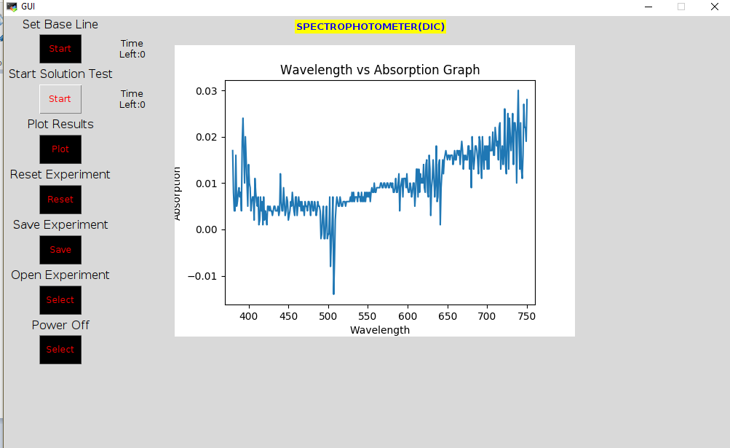

3) Water test: In this test we just have to take simple distilled water. In this the sampled solution is also water

4)  Milk fat test: In this test we have taken different fat concentration of milk. In this first take a plane water for the baseline solution. The steps performed for the experiment are discussed below.

• Milk with different fat percentage was collected from Verka booth.

• Two variants that were used in the experiment had 1.5% and 4.5% fat content respectively.

• The samples were taken in cuvette one by one and analysed throughout the range of visible spectrum.

• The readings were noted and plotted for the study.

**RESULTS:**

1. The salt solution test shows that with increase in concentration of salt in water the absorption rate increases and the graph shifts upward.

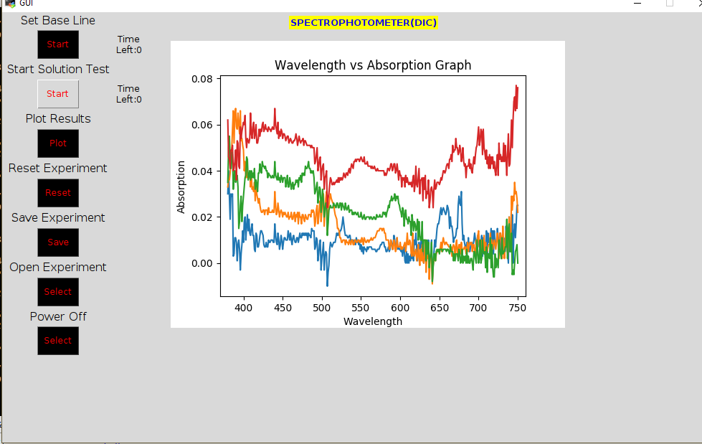

COMPARED WITH ORIGINAL:

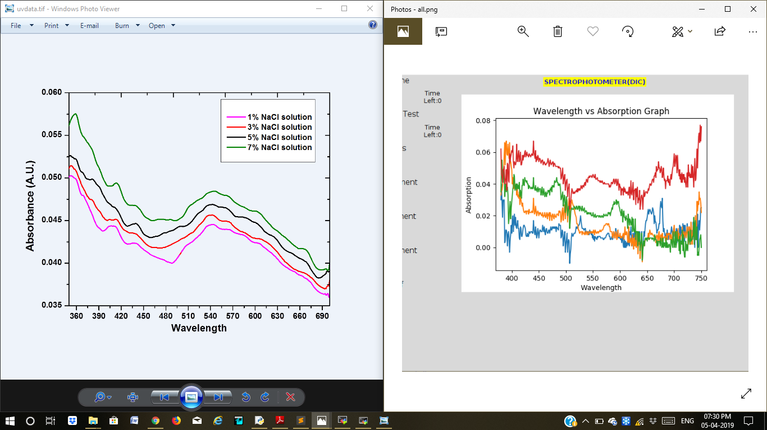

1. The sugar solution test shows that with increase in concentration of salt in water the absorption rate increases and the graph shifts upward.

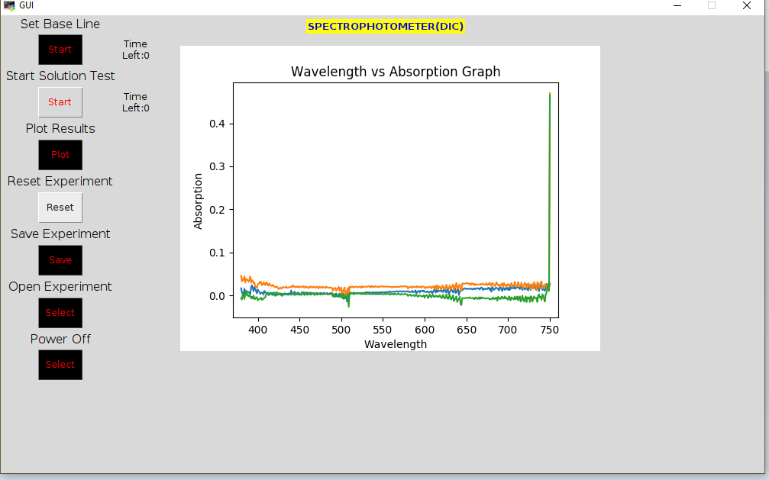

1. In plain water test the graph remain constant. The value of absorption remain 0 , because the sampled solution is also same so the intensity detected by the sensor remain same(so by byot severtz law the graph remain constant.

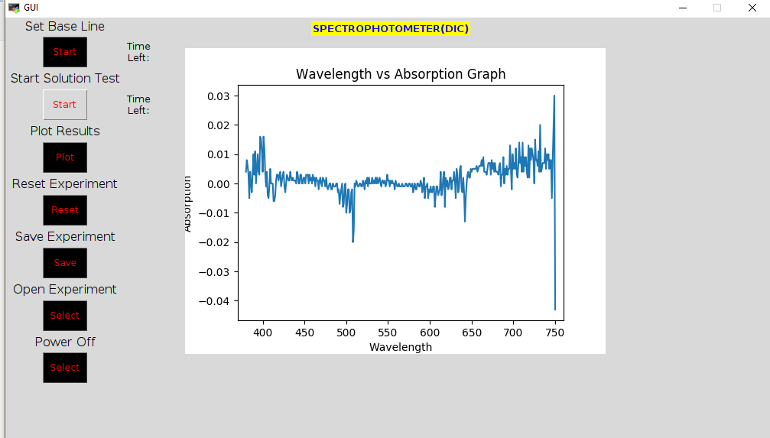

4) In this milk fat test we observe that with increase in concentration of the fat in milk , the graph shifts upward. This means that the absorption increases with increase in fat concentration in milk.

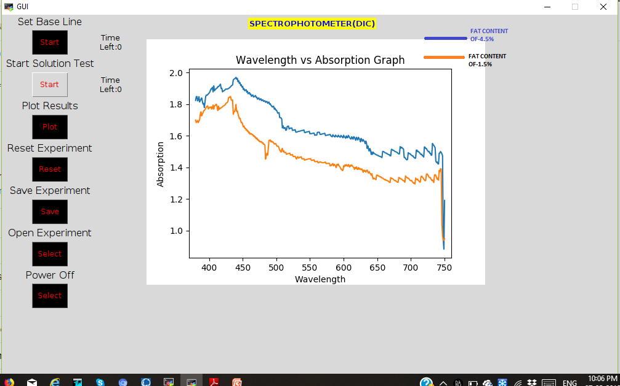

**CONCLUSION:**

With the wide range of applications, it is really useful to have a low-cost replacement for the Spectrophotometer. With the reduction in cost and size, it shall become handier to use for a variety of other experiments. Hence from our spectrophotometer we are able to compare the fat concentration of different liquid. .For example, it can be used to check adulteration in samples of milk, blood or other solutions. Based on the experiments performed on the prototype made to replace a spectrophotometer, it can be concluded that it is possible to produce a low-cost spectrophotometer that can perform various experiments with accuracy comparable to the actual spectrophotometer. This can be used as a product in high-school and college laboratories to understand the basics of spectroscopy. Also, it is necessary to block noise from the external environment to provide repeatability and robustness in the experiments. It is important to know and acknowledge the point where the spectrophotometer loses its linearity property, that is, where the transmittance is not linear to the concentration of solution anymore. It’s also necessary to address the changes in the apparatus when the components are replaced. A form of calibration thus becomes necessary in such cases. Based on the experiments performed during the course of internship, it can be stated that besides high-schools and colleges, this prototype can be put to various other uses such as determining the fat content in milk at an industrial level. The wide market for this product can be a source of huge revenue. When calibrated properly, this can be used to perform various classification tests and tests like estimation of protein concentration in human blood

**FUTURE SCOPE:**

With reducing the cost of electronics and increasing computational power of computers, it becomes feasible to make a spectrophotometer that can be used to perform tests on the more regular basis . A lot of work is being done towards making it possible to perform spectrophotometer using smart phones. Now further we can use this IR source for this spectrophotometer so that our results are more precise than others.We can also use a UV source and detector for further precision of results. Moreover we can transfer all the collected data to cloud so that we can access and modify this data from anywhere.

**MODEL:**

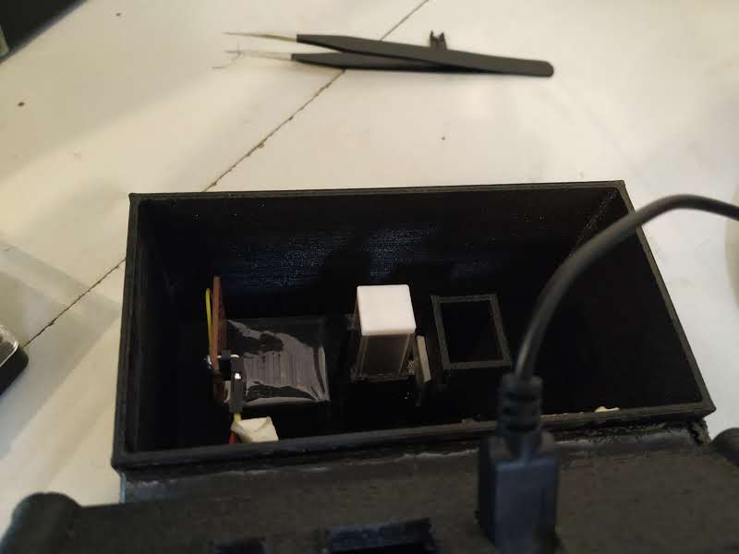

 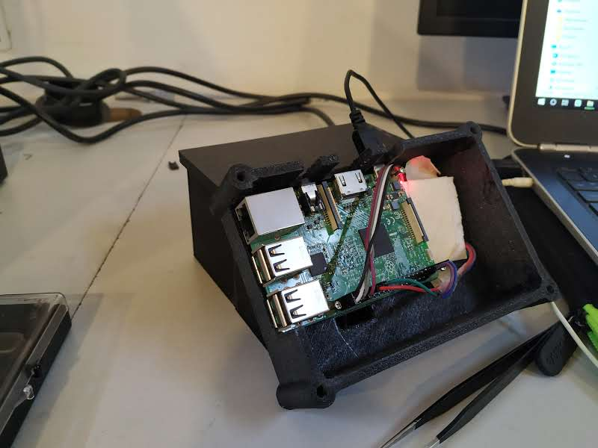

**REFERENCES:**

* 1). Atkins, Peter and Julio de Paula. Physical Chemistry for the Life Sciences. New York: Oxford
* University Press, 2006.
* 2). Chang, Raymond. Physical Chemistry for the Biosciences. USA: University Science Books, 2005.
* 3)<https://hannainst.in/products/spectrophotometers.html>
* 4)https://www.instructables.com/id/Lux-Sensor-TSL2561-Raspberry-Pi/